Date of issue: January 24, 2020

Project Manager: Gilbert Obodo

DOUH HOSPITAL MANAGEMENT SYSTEM (DOUH HMS) System analysis & Design Project

# Approvals

Client: Joey Kitson

Title: Instructor

**DOUH Hospital Management System (DOUH HMS) System Analysis & Design**

This document is to bear the approval of the person(s) in charge of the DOUH Hospital Management System project, to confirm that they approve of the plans laid within this document. If signed, they take responsibility for all changes proposed within and agree that they have read them over thoroughly and fully. If the changes proposed within are accepted, please date and sign at the bottom of this document to confirm moving forward with the project as outlined.

**Client:**

Joey Kitson

Signature Date

**Project Manager:**

Gilbert Obodo January 24, 2020

Signature Date

# Document Tracking

|  |  |  |  |  |
| --- | --- | --- | --- | --- |
| **Version** | **Date** | **Released** | **Recipients** | **Comments** |
| Vs1.0 | January 24, 2020 | Gilbert Obodo |  | This is the first version of the stated document |
|  |  |  |  |  |
|  |  |  |  |  |

Table of Contents

Approvals 1

Document Tracking 2

Management Summary 5

System Overview 6

System Statement 6

System Deliverables/Assumption/Constraints 6

Deliverables 6

Non-Deliverables 7

Assumptions 7

Constraints 8

System Key Requirements 8

Outputs 8

Inputs 8

Data 8

Process 9

Security 9

System Modelling 10

Event Table 10

Domain Class Diagram 12

Use Cases 13

View patient information 15

View patient medical history 16

View Nurses list 16

Use case detailed description 17

Sequence diagrams for the Use Cases 31

System Component Details 36

Program Design 36

Class Diagram 36

Sequence Diagram (Multi-Tier) 37

Package Diagram 41

Output Design 42

View Doctors Report & Mock-up 42

View Nurses Report & Mock-up 44

View Patients Report & Mock-up 46

View Patients medical Record 48

Input Design 50

Register a patient mock-up form 50

Doctor and Nurse Registration 50

Create Medical Record 51

Database Design 52

ERD of the entire system 52

DateBase Design Language (DBDL) 53

Database Dictionary 54

Support Processing Design 57

Environmental Requirement 57

Hardware required by the new system 57

Software required by the new system 58

Implementation Requirements 59

Data conversion/data entry requirements 59

Security consideration and levels of access to the system 59

Approach and recommendation for system changeover 59

Training Requirements 60

Post-implementation reviews 60

# Management Summary

Hospitals are an indispensable institution and a vital part of human lives as they provide medical services to people faced with diverse kinds of ailments. It has become necessary for hospitals to adopt an efficient way of tracking its day-to-day activities and records of its Patients, Nurses, and Doctors for a smooth and effective management of their operations. It also needs to deviate from the paper records system which is, not only inefficient and time consuming, but also cumbersome and vulnerable to all forms of attacks and risks considering the large number of patients records in their custody.

The DOUH Hospital Management System (DOUH HMS) is a standalone application that is designed to overcome the above-mentioned challenges facing most hospitals. With the application, which will be online 24/7, Patients can sign up/login to book appointments to see a Doctor, view and modify their personal information. Nurses and Doctors are also able to use the system to retrieve and manage Patients medical records and add notes on the Patient’s diagnosis. System Administrator assigns permissions to the system users to ensure a secured use of the system. The Administrator is the only one who has the right to delete any record from the system.

The DOUH Hospital Management System is a software product suite intended to improve the quality and management of DOUH hospital management in the areas of clinical process analysis and activity-based costing. The System will enable the hospital to improve their organizational efficiency and improve their effectiveness and quality of work.

This document provides the details of all the system design, showing all the deliverables and non-deliverables. It also shows the system requirements which includes the sub-systems the application supports. This document also shows the constraints and assumptions which focuses on the business rules and items within the programming areas. The system modelling is also included here, identifying the use cases the system supports, alongside system components details including the class diagram and package diagram. Database design details, environmental requirements, and the system implementation requirements are also included in this document.

A strict compliance to the business rules, and the outlined system requirements are critical to the implementation of this system and thereby needs to be adhered to ensure the delivery of planned system.

# System Overview

## System Statement

The overall objective of this project is to analyze, design and deploy a DOUH Hospital Management System (DOUH HMS) to meet the requirements for the completion of CIS-2261. The project is intended to add value to the wide varieties of functions involving the hospital Patients, Doctors, Nurses, and System Administrator. Patients will be able to book and manage appointments, Nurses will be able to book and manage appointment, update the patient’s vital signs records, and also view notes on a Patient’s diagnosis, Doctors will be able to view their schedules and also attend to patients and update their medical record, while System Administrator shall be able to manage the system users. It is our plan to deliver a world-class, user-friendly system that will be a reference point to other Hospital management systems.

DOUH Hospital Management System can be accessed using a username and password. It can be accessed by an Administrator, a Nurse, Doctor, or a Patient. The users can perform certain activities based on the security level or rights assigned to them by the Administrator. The system automatically assigns an id to patients who register an account. The system also automatically adds data from the users to the database. Data can be retrieved easily any time by the users. The user interface is well designed and very user-friendly. The data are well protected for personal use and makes the data processing very fast.

## System Deliverables/Assumption/Constraints

## Deliverables

* Developed user-friendly interfaces
* Patient can register an account
* Patients information are stored
* Patient can book appointment
* Users can view, edit, and update their profile
* Users can login using their username and password
* Users have levels of permissions in using the system
* Doctor can add notes to a Patient’s diagnostic record
* Nurse can view Doctor’s note on Patient’s record
* Doctors can see their schedules
* Nurses can book an appointment for a Patient
* Admin can create accounts for Doctors and Nurses
* Nurses can create Patients medical record
* Nurses and Doctors can view a Patient's medical history
* Admin can delete Patient, Nurse, and Doctor account

### Non-Deliverables

* Wish-list of the client
* Wish-list of the users
* Interface to third party payment systems
* Hardware and software components required to deliver the intended value from the project

### Assumptions

* Team members are knowledgeable in the use of the analysis and design tools
* The client is available for clarifications on the requirements.
* The hospital will provide the hardware that meets the minimum requirements to implement the software.
* The hospital will provide for enough resources and timeframe needed to implement the software.
* The project will follow the business standards of operations.
* Each user must have a valid username and password
* Only the Administrator can delete records
* Server must be running for the system to function
* Users must log into the system to access any record

## Constraints

* The timeline for the analysis and design of the system is 24 days which might not be enough for the delivery of the outcome of the effort
* The project budget is $4,760.00
* The project team size of four (4) people for work that needs to be done.
* Employees may require basic computer skills training to successfully complete Software training.

## System Key Requirements

### Outputs

* Admin can search for a patient with the help of the health card number or date of birth and view patients’ details
* Admin can view doctors, patients, and appointments
* A doctor can view a patient's appointment history
* A doctor can view his schedule
* Patients can view their profile, see their appointment and personal information,
* Nurses shall be able to view notes on a Patient’s diagnosis

### Inputs

* Nurses shall be able to update a patient’s vital signs records,
* Doctors should be able to add notes on a patient’s diagnosis
* Nurses shall be able to add notes on the outcome of a patient’s visit

### Data

* Patient personal information
* Login credentials
* Nurses personal information
* Doctors personal information
* Patient medical records
* Doctors diagnostic notes
* Nurses notes

### Process

* A patient can book and appointment
* Online access – Users shall be able to have online access to the system
* A doctor can search a patient with the help of the patient's health card number or date of birth
* Nurses will be able to book and manage appointment for a patient

### Security

* Ability for users to be uniquely identified and verified when logging in for online programs
* There shall be levels of permissions on what users are able to do on the system

## System Modelling

### Event Table

|  |  |  |  |  |  |
| --- | --- | --- | --- | --- | --- |
| Event | Trigger | Source | Use case | Response | Destination |
| Patient account creation | New patient | Patient | Patient sign-up | Patient username/password  Patient ID | Patient  System |
| Patient update personal information | Update patient personal details | Patient | Update personal information | Patient personal information | Patient  System |
| View patient account | Patient summary | Patient | View patient information | Patient personal information | Patient  System |
| Doctor account creation | New doctor | Admin | Create doctor account | Doctor username/password  Doctor ID | Doctor  Admin  System |
| Doctor update information | Update doctor information | Doctor | Update doctor information | Doctor account | System  Doctor |
| Doctor enter diagnose | Enter patient diagnose | Doctor | Enter patient diagnose | Diagnose | Doctor  Patient  System |
| Nurse account creation | New nurse | Admin | Create nurse account | Nurse username/password  Nurse ID | Nurse  Admin  System |
| Nurse update information | Update nurse information | Nurse | Update nurse information | Nurse account | System  Nurse |
| Nurse enter vital information | Check up | Nurse | Get vital information | Vital information | Patient  System  Nurse |
| Admin wants to sign in. | Admin adds doctors and nurses. | Admin | Admin login | Successful sign in | System |
| Admin wants to create login for Doctor. | Doctor account needs to be created. | Doctor / Admin | Create Doctor Account. | Doctor account created | Admin  System |
| Admin wants to create login for Nurse | Nurse account needs to be created. | Nurse / Admin | Create Nurse Account. | Nurse account created | Admin  system |

### Domain Class Diagram

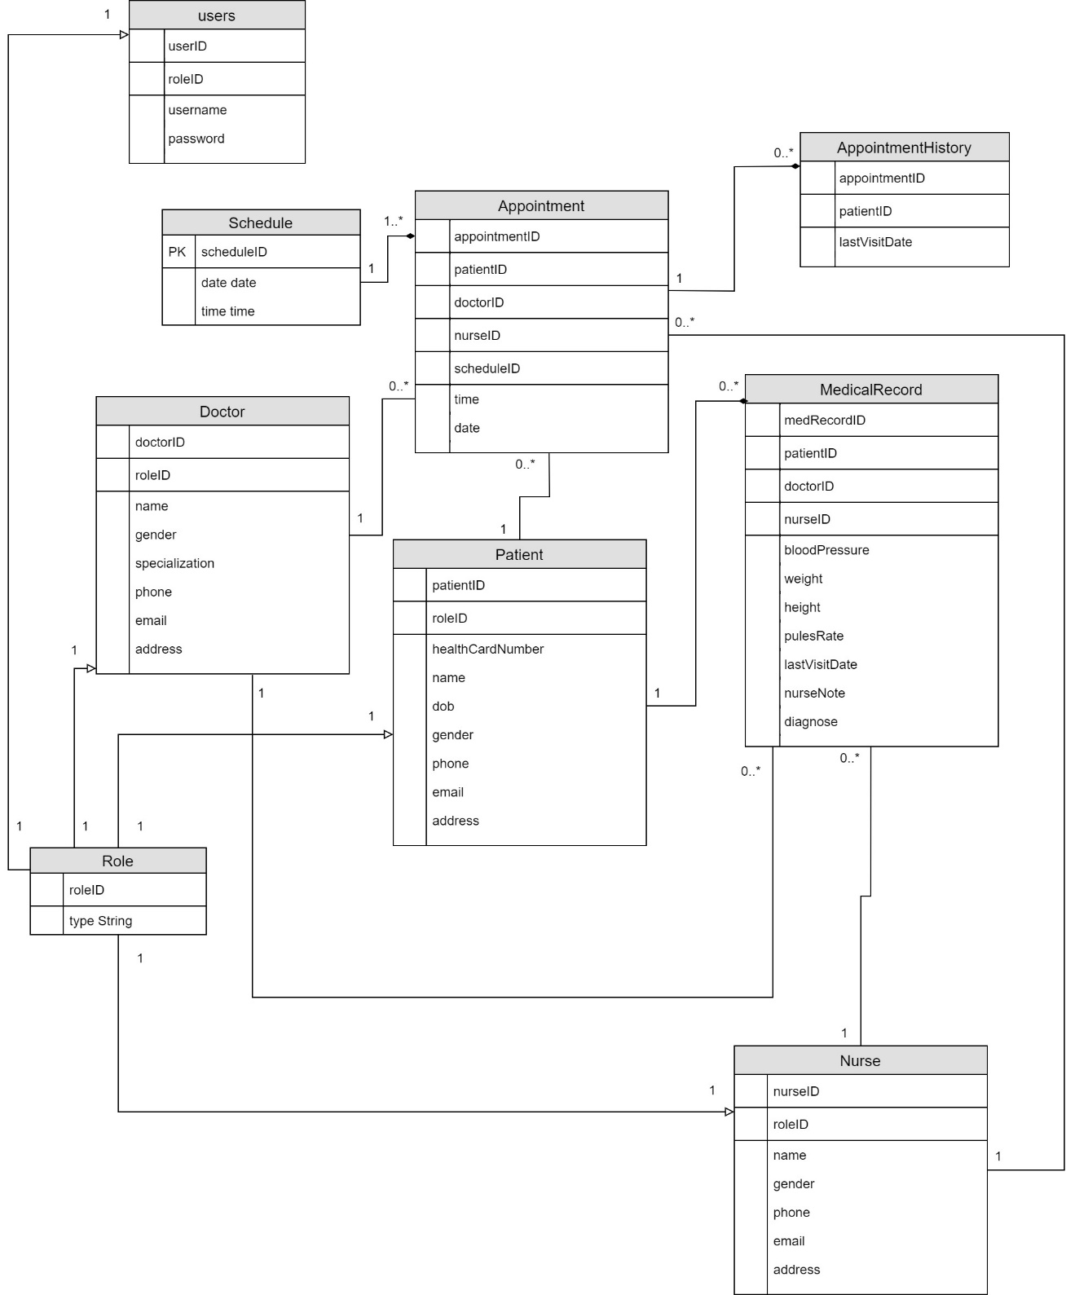

### Use Cases

#### Create Doctor account

The admin creates the doctor account by allocating the doctor role and entering the basic doctor details to create the doctor account.

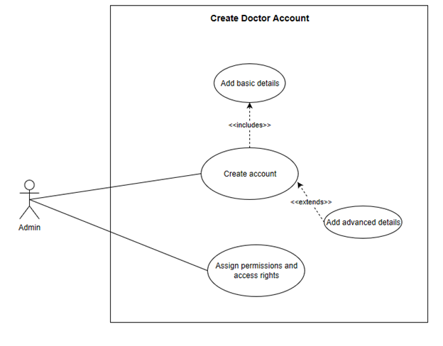

#### Create Nurse account

The admin creates the nurse account by allotting the nurse role and entering the basic nurse details to create the nurse account.

#### 

#### Register a patient

The patient can register as a patient by entering his health card number and then entering his basic information. The patient can update his information.

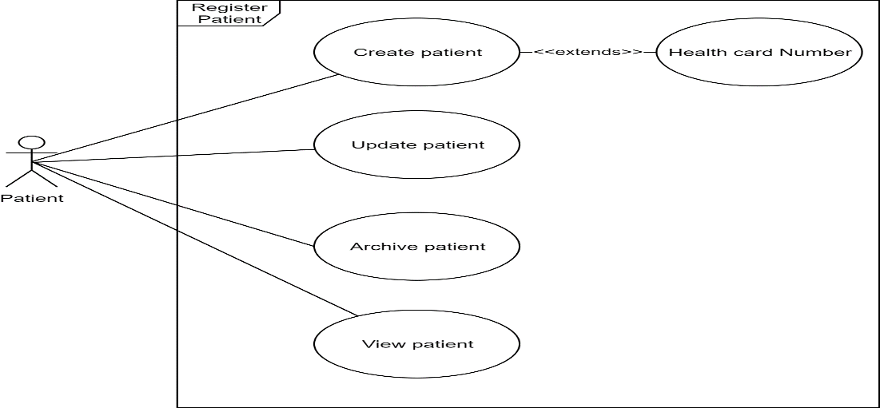

#### Nurse Create patient medical record

The nurse can create update a patient Medical Record when the patient books an appointment with the doctor. The nurse can update patient medical record with the patient vital information.

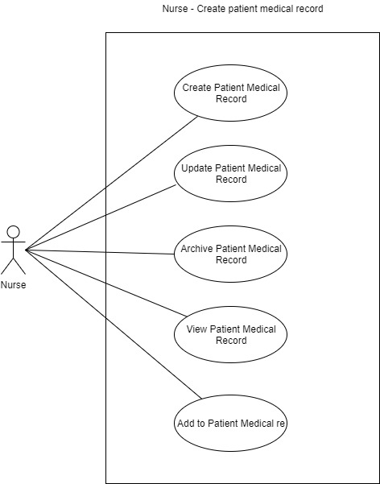

## View patient information

The patient can login to the system and view the account information. The patient is able to book an appointment with the doctor.

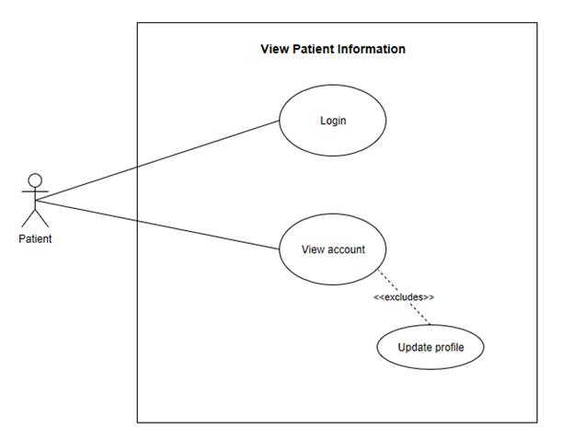

#### View Doctors’ list

The patient can login to the system to view the doctors list and their specialty. The patient can then book and appointment with the doctor on the Doctor’s list.

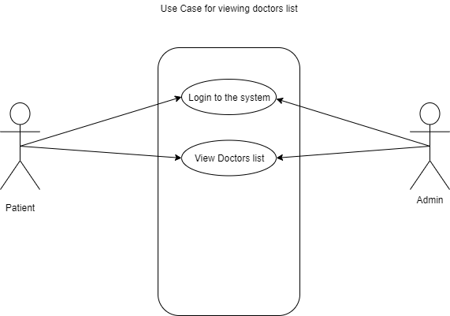

## View patient medical history

The doctor can login to the system and select a patient to see the patient history and the medical record.

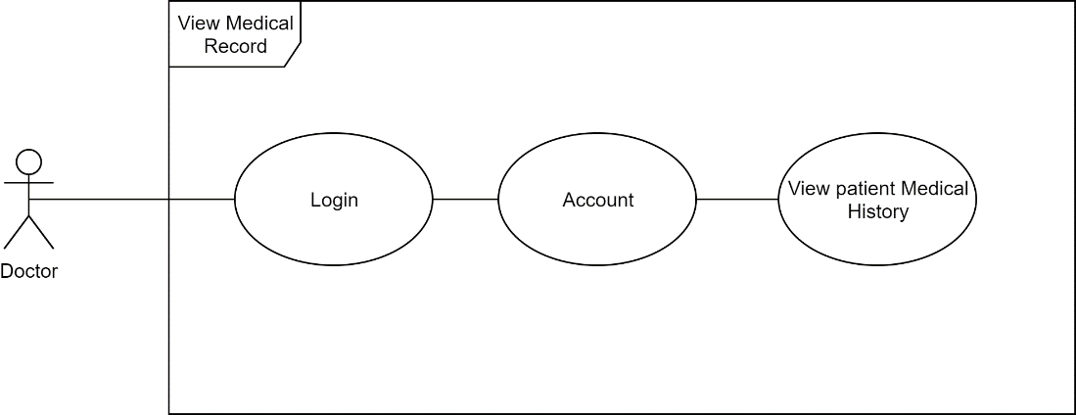

## View Nurses list

The nursing manager can login to the system and see the list of nurses. The nursing manager can assign nurse to doctor and make a schedule for the nurses.

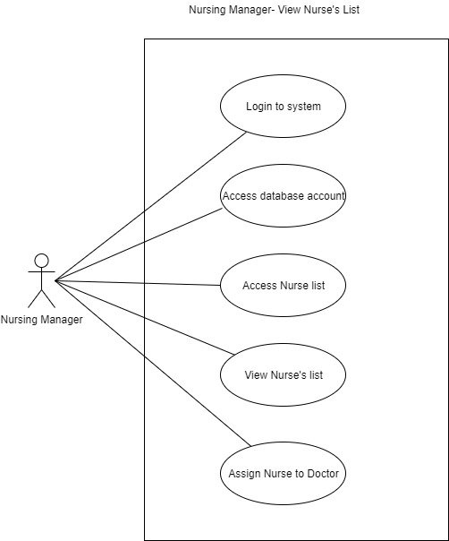

### Use case detailed description

#### Create Doctor account use case description

|  |  |  |
| --- | --- | --- |
| **Use case name:** | Create Doctor Account |  |
| **Scenario:** | An Admin wants to create an account for a new doctor |  |
| **Triggering event:** | New Doctor |  |
| **Brief description:** | A new Doctor joins the hospital and does not have the rights to create an account for himself. System Administrator needs to create an account for the new Doctor |  |
| **Actors:** | Admin |  |
| **Related use cases:** | Create Nurse account, Register a Patient |  |
| **Stakeholders:** | Admin  Doctor |  |
| **Preconditions:** | A Doctor account subsystem must be available |  |
| **Postconditions:** | Doctor must be created and saved.  Doctor ID must be provided for the Doctor.  The new ID and account details must be associated to the Doctor  Doctor must have a username and password created |  |
| **Flow of activities:** | **Actor** | **System** |
|  | 1. Admin gathers all the details required for account creation      1. Admin enters basic information to create an account (name, phone, email, password). | * 1. System prompts for basic information to create account.      * 1. System validates Doctor’s information is not in the system and no empty fields   2. System creates account.   3. System provides Doctor ID and login details. |
| **Exception conditions:** | 2.1 Inaccurate/invalid data type of personal information |  |

#### Create Nurse account use case description

|  |  |  |
| --- | --- | --- |
| Use case name | Create nurse account |  |
| Scenario | Creating nurse account for the hospital |  |
| Triggering Event | Hospital require nurse and admin will create nurse account |  |
| Brief description | A nurse account has personal information when he/she joins in a hospital. Admin will create his/her her account with respective user login credentials along with personal information. |  |
| Actor | Admin |  |
| Related use case | Creating doctors account |  |
| Stakeholder | Admin, Nurse |  |
| Precondition | A nurse is not allowed to create his/her own account |  |
| Postcondition | A nurse is not allowed to delete his/her own account |  |
| Flow of activities | |  |  | | --- | --- | | Actors | System | | 1. Admin creates nurse account with appropriate information. 2. Admin assign a nurse with appropriate role in the system. | 1.1 System will allow the admin to create nurse account.  1.2 System creates new nurse account.  2.1 Systems updates information and save to database | | |
| Exception | Provided information is invalid | |
| Condition | Admin need to enter valid nurse’s information | |

#### Register a patient use case description

|  |  |  |
| --- | --- | --- |
| **Use case name:** | Register patient |  |
| **Scenario:** | Patient want to book an appointment with a doctor/ specialist |  |
| **Triggering event:** | New patient |  |
| **Brief description:** | A patient uses the website to create a new account. |  |
| **Actors:** | Patient |  |
| **Related use cases:** | Sign up doctor/ Sign up Nurse. |  |
| **Stakeholders:** | Admin  Patient |  |
| **Preconditions:** | None |  |
| **Postconditions:** | A new account created.  Patient ID provided to the new member.  Patient has a username and password. |  |
| **Flow of activities:** | **Actor** | **System** |
|  | 1. Patient clicks on the ‘Sign up’ link on the website.      1. Patient enters basic information to create an account (name, phone, email, password). | * 1. System prompts for basic information to create account.      * 1. System validates patient information is not in the system and no empty fields   2. System creates account.   3. System provides patient ID. |
| **Exception conditions:** | 2.1 Inaccurate/invalid data type of personal information |  |

#### Create patient medical record use case description

|  |  |  |
| --- | --- | --- |
| **Use case name:** | Create Patient medical record. |  |
| **Scenario:** | Nurse wants to create a Patient medical record to keep track of patient diagnosis. |  |
| **Triggering event:** | Patient comes for treatment to the doctor. |  |
| **Brief description:** | The nurse creates the patient medical record which the doctor can see and update during treatment and diagnosis. |  |
| **Actors:** | Nurse  System |  |
| **Related use cases:** | Patient login and makes appointment with the doctor. |  |
| **Stakeholders:** | Nurse  Doctor  Patient |  |
| **Preconditions:** | Patient account must be created. Patient must have a doctor appointment. |  |
| **Postconditions:** | Patient medical record created.  Patient medical history can be viewed by doctor and nurse for treatment and diagnosis. |  |
| **Flow of activities:** | **Actor** | **System** |
|  | 1. Nurse clicks on Create Patient medical record button. 2. Nurse enters the patient vital medical information (height, weight, blood pressure, body temperature.) 3. Nurse updates Nurse notes in the medical record | 1. System creates a blank form for Patient medical history to be entered. 2. System saves the data entered into the database. System confirms all essential entries are filled otherwise prompts to fill in the vital medical information. 3. System confirms Medical record created and saved. |
| **Exception conditions:** | 1. Database not accessible or network failure. Display failure message |  |

#### View patient information use case description

|  |  |  |
| --- | --- | --- |
| **Use case name:** | View Patient Information |  |
| **Scenario:** | A Patient wants to see his account information |  |
| **Triggering event:** | Account summary |  |
| **Brief description:** | A Patient wants to get into his account to view his personal profile information on file. |  |
| **Actors:** | Patient |  |
| **Related use cases:** | View Patient medical history, view Doctor’s notes on Diagnosis |  |
| **Stakeholders:** | Patient  Admin |  |
| **Preconditions:** | Patient account must be in the system  Patient must have valid login credentials |  |
| **Postconditions:** | Patient will be able to view his personal profile information |  |
| **Flow of activities:** | **Actor** | **System** |
|  | 1. Patient logs into system with his username and password     1. Patient navigates to his profile tab 2. Patient views his profile information | * 1. System is initialized and Patient is authenticated.   2. System displays tabs for navigation   3. System displays Patient profile information on file |
| **Exception conditions:** | * 1. User cannot be authenticated, request for email or password recovery.   2.1 GUI is not responding, display error message  3.1 Database could not be reached, display network failure message |  |

#### View Doctors’ list use case description

|  |  |  |
| --- | --- | --- |
| **Use case name** | View Doctors list |  |
| Scenario | Viewing doctors list |  |
| Triggering Event | Admin/Patient wants to see available doctors list |  |
| Brief description | When a patient wants to book an appointment, he/she will have the ability to select the doctor based on the speciality of doctors that are available. The admin is also able to view the listing of doctor to perform administrative operations on the system. |  |
| Actor(s) | Patient, Admin |  |
| Related use case | View Nurses/patients |  |
| Stakeholder | Patient/admin/doctor |  |
| Precondition | Login to the system |  |
| Postcondition |  |  |
| Flow of activities | |  |  | | --- | --- | | Actors | System | | 1. Patient wants see doctors listing. 2. Admin wants to see doctors listing for administrative operations. | 1.1 System allow the patient to look at the doctors list.  1.2 Systems shows the doctors that are available.  2.1 System show all the doctors listing | | |
| Exception |  | |
| Condition | Login to the system before look into the listing of doctors. | |

#### View patient medical history use case description

|  |  |  |
| --- | --- | --- |
| **Use case name:** | View patient medical history |  |
| **Scenario:** | Doctor and nurse want to check the patient medical Record |  |
| **Triggering event:** | Doctor revise a patient case |  |
| **Brief description:** | A doctor wants to check patient medical history for a patient |  |
| **Actors:** | Doctor/Nurse |  |
| **Related use cases:** | View doctors/ view patients/ view nurses |  |
| **Stakeholders:** | Patient/Doctor |  |
| **Preconditions:** | Doctor should be sign in  Patient should be registered |  |
| **Postconditions:** | Display the patient medical record |  |
| **Flow of activities:** | **Actor** | **System** |
|  | 1. Doctor clicks on the ‘view a patient medical record’      1. Doctor view medical history information (bloodPressure, weight, height, pluseRate, lastVisitDate,nurseNote, diagnose). 2. Doctor might update medical history Information | 1.1 System provides patient Medical History.  3.1 System update medical information |
| **Exception conditions:** | 1.1 Patient does not have medical record |  |

#### View Nurses list use case description

|  |  |  |
| --- | --- | --- |
| **Use case name:** | View Nurse’s List |  |
| **Scenario:** | Nurse Manager wants to view the list of Nurse’s to allocate them to the Doctor’s. |  |
| **Triggering event:** | Schedule nurse’s to Doctor. |  |
| **Brief description:** | Nurse manager uses the nurse list to allot them to the Doctor’s |  |
| **Actors:** | Nurse Manager / System |  |
| **Related use cases:** | Nurse login / Updating nurse schedule |  |
| **Stakeholders:** | Nurse / Doctor / Nurse Manager |  |
| **Preconditions:** | None |  |
| **Postconditions:** | Nurse duty allotted to Doctor.  Nurse schedule made. |  |
| **Flow of activities:** | **Actor** | **System** |
|  | 1. Nurse Manager logs in to the system. 2. Nurse Manager enters username and password. 3. Nurse Manager calls for all the available nurse’s 4. Nurse manager assigns nurse to Doctor. | 1. System prompts for login and password for authentication. 2. System authenticates the user. 3. System displays list of all Nurse’s. 4. System updates the Nurse schedule. |
| **Exception conditions:** | 1. No nurse is available for work. |  |

### Sequence diagrams for the Use Cases

#### System Sequence Diagram for Create Doctor account use case

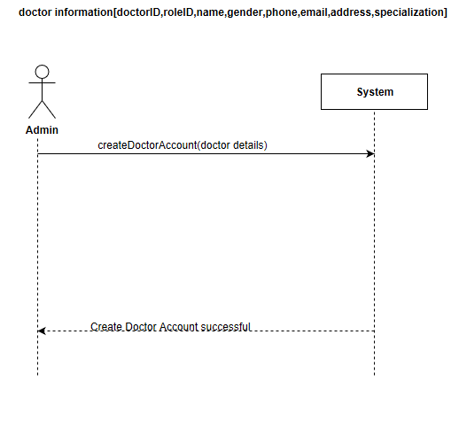

#### System Sequence Diagram for Create Nurse account use case

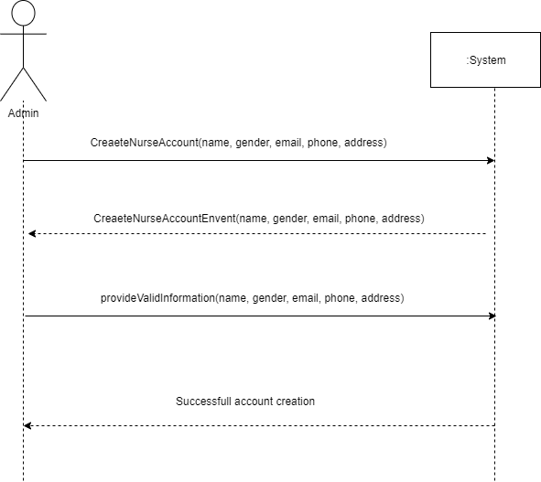

#### System Sequence Diagram for Register a patient use case

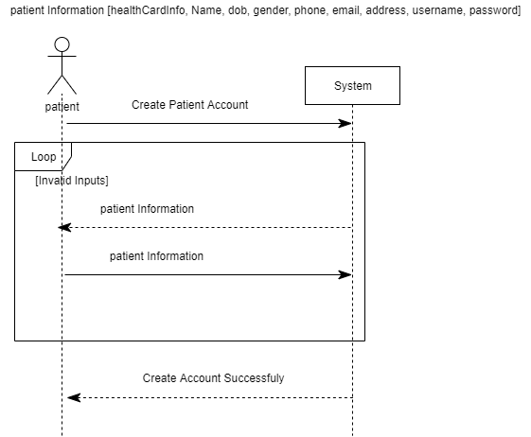

#### System Sequence Diagram for Create patient medical record use case

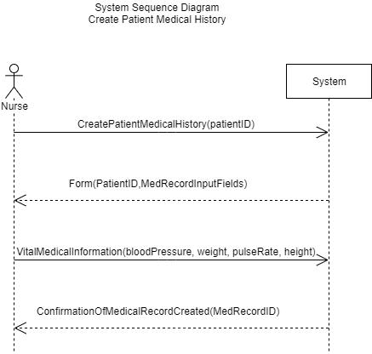

#### System Sequence Diagram for View patient information use case

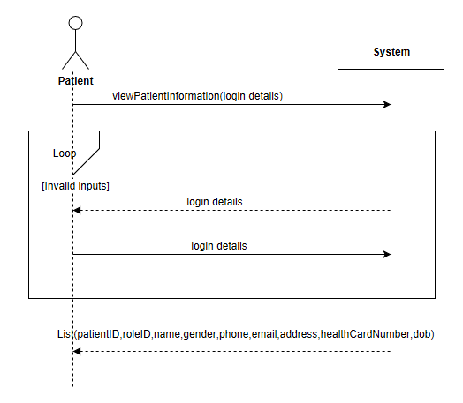

#### Sequence Diagram for View Doctors’ list use case

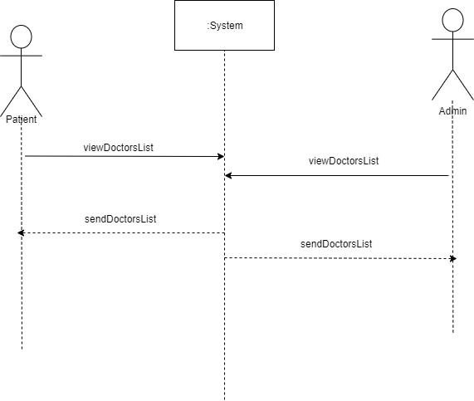

#### System Sequence diagram for View patient medical Record History use case

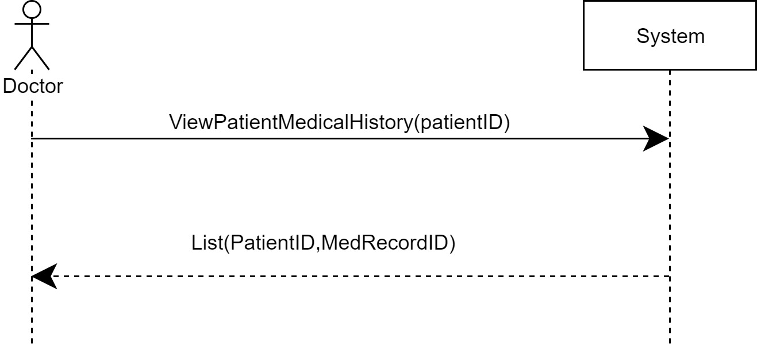

#### System Sequence Diagram for View Nurses list use case

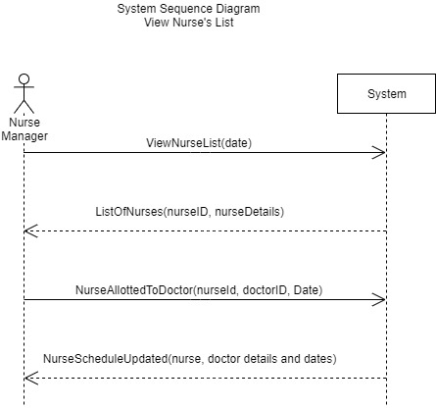

# System Component Details

## Program Design

### Class Diagram

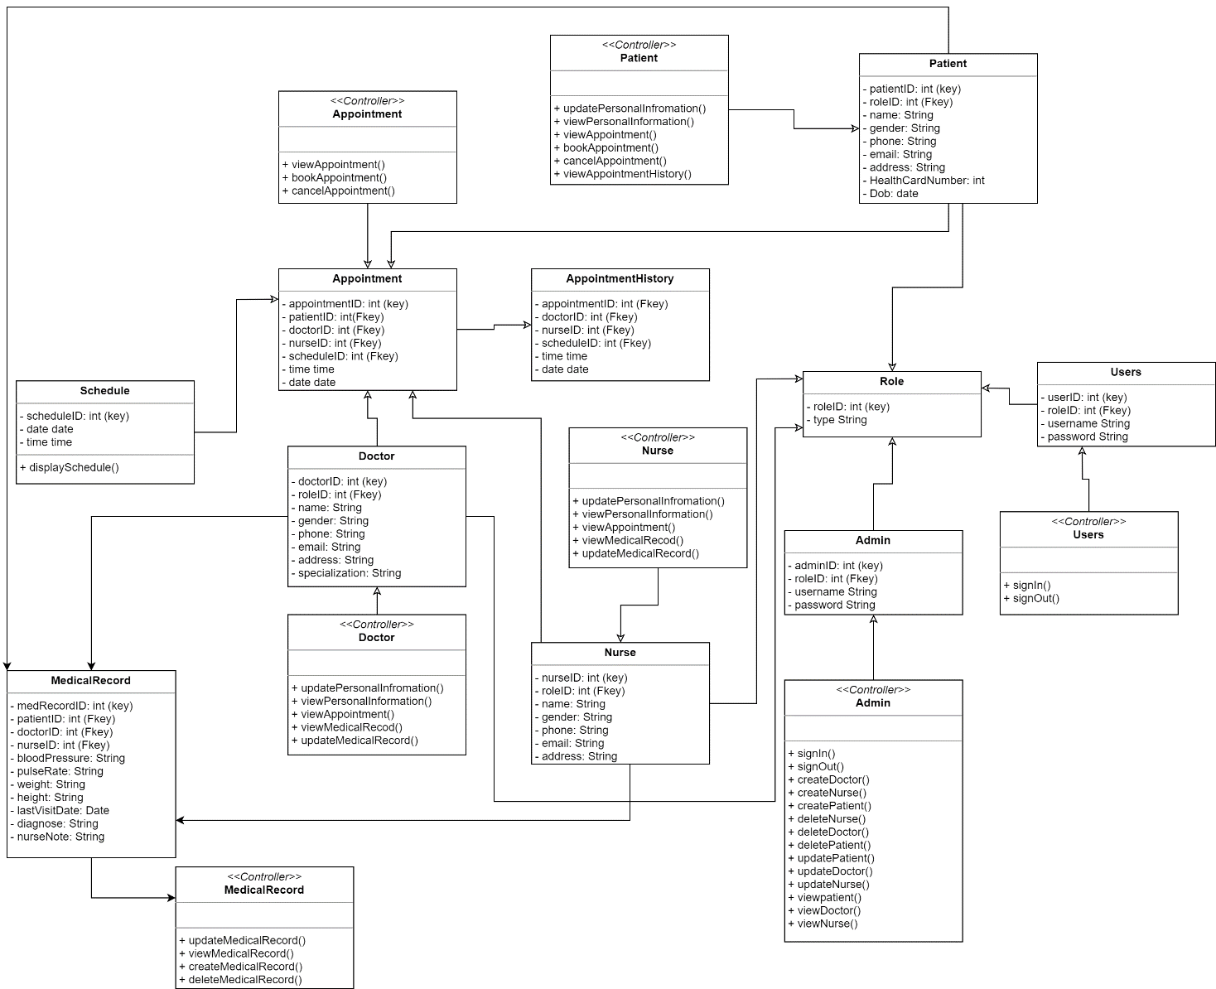

### Sequence Diagram (Multi-Tier)

Sequence diagram(multi-tier) for Create Doctor account

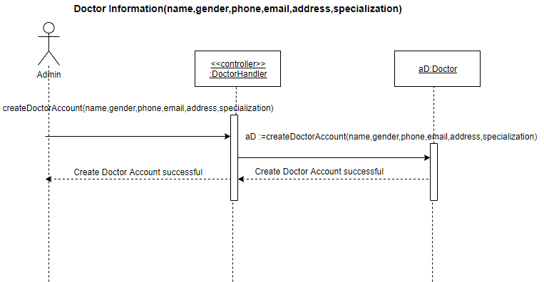

#### Sequence diagram(multi-tier) for Create Nurse account

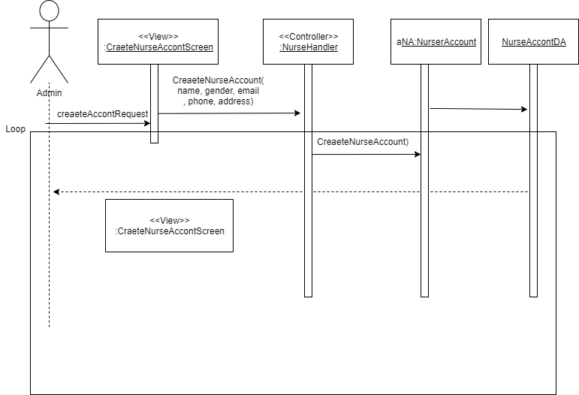

#### Sequence diagram(multi-tier) for Register Patient

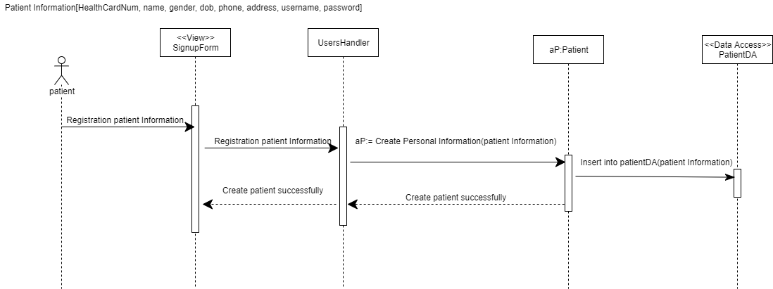

#### Sequence diagram(multi-tier) for view Patient Information

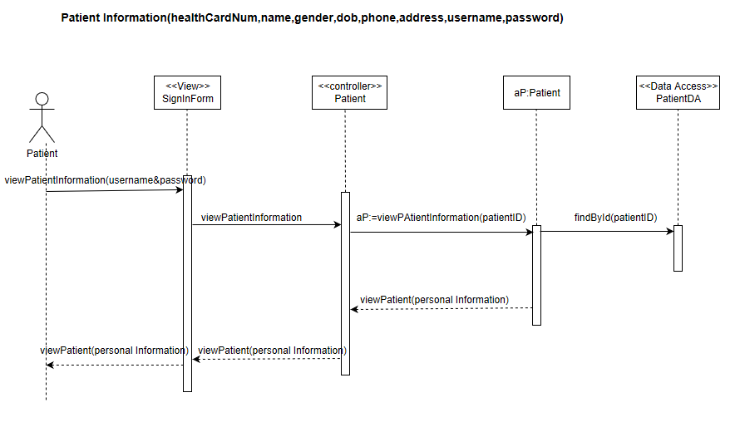

#### Sequence diagram(multi-tier) for viewing doctors list

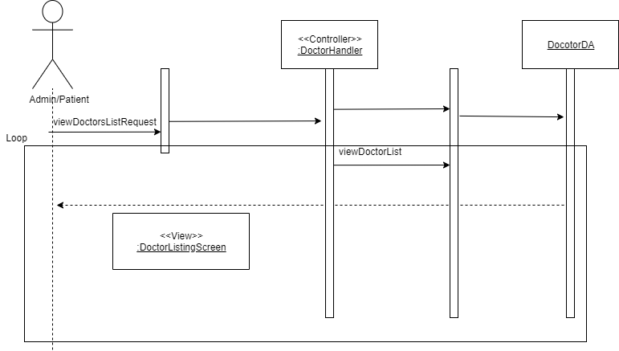

#### Sequence diagram for a view patient medical Record History use case

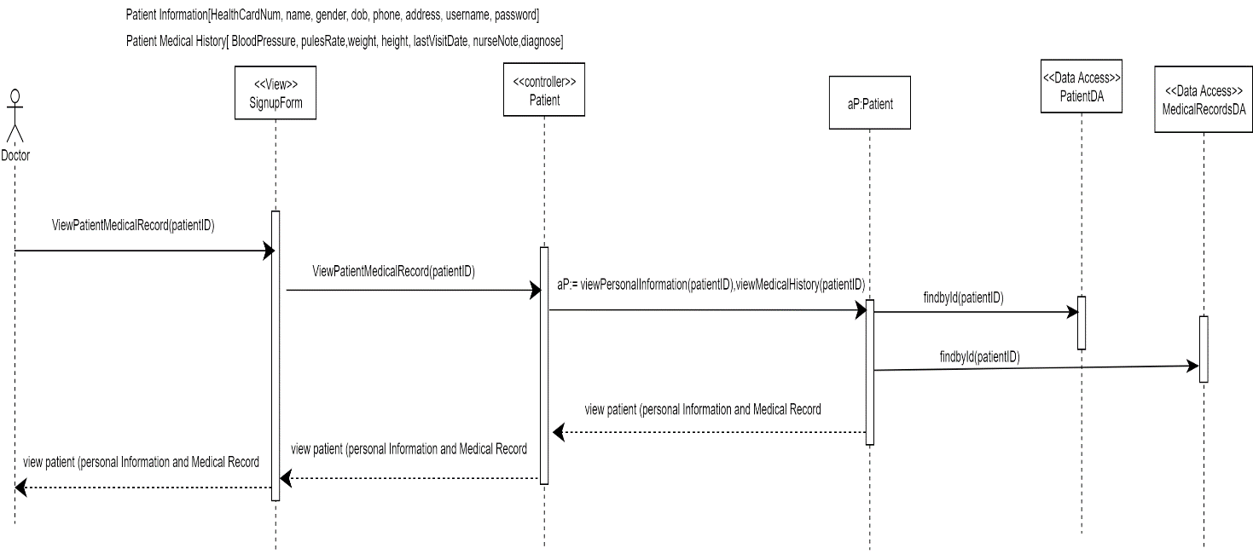

#### Sequence diagram for view Nurses list

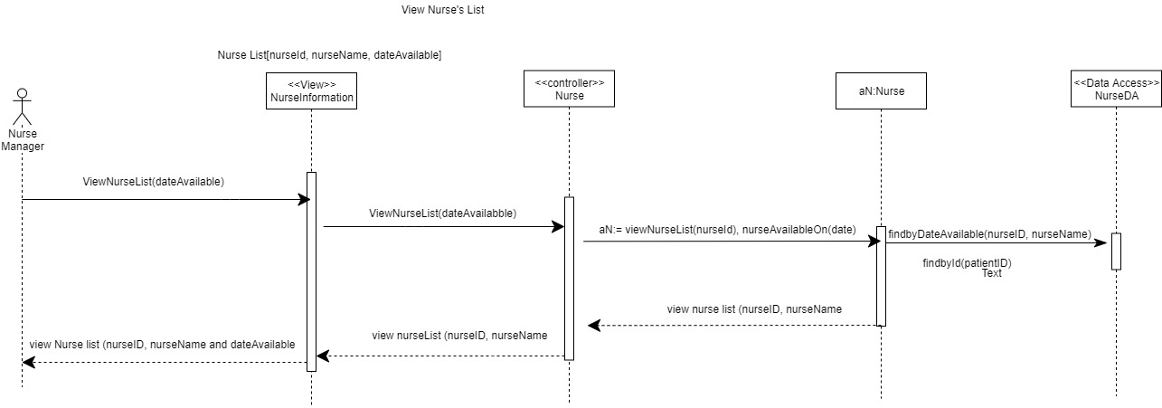

### Package Diagram

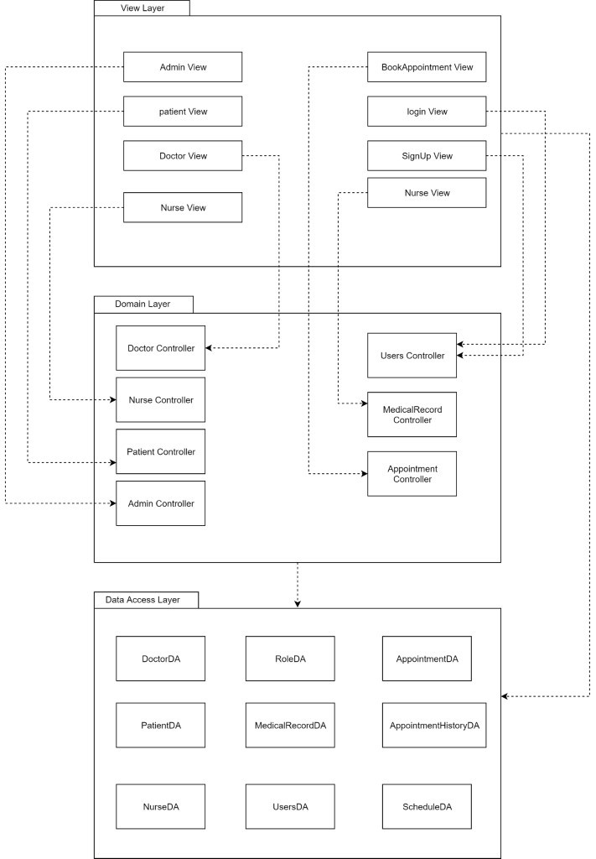

## Output Design

### View Doctors Report & Mock-up

**SYSTEM DOCUMENTATION**

NAME OF SYSTEM DATE PAGE 1 OF 2

Reports System 24-01-2020

ANALYST PURPOSE OF DOCUMENTATION

Amro Daas Generate and display a List of all the doctors

|  |  |  |
| --- | --- | --- |
| FIELD | FIELD TYPE | FIELD LENGTH |
| doctorID | Numeric | 10 |
| name | Alphanumeric | 255 |
| gender | Alphanumeric | 255 |
| specialization | Alphanumeric | 255 |
| phone | Numeric | 10 |
| address | Alphanumeric | 255 |
| email | Alphanumeric | 50 |

COMMENTS

1. doctorID will be displayed at the top of the report.

SORT SEQUENCE

Detail lines are in order by doctorId or it can be order based on an alphabetic.

TOTALS REQUIRED

Not Applicable

MEDIA

1. This report can be displayed on the screen.
2. This report can be printed on regular A4 paper.
3. This report can be exported to Excel format

FREQUENCY

The report is printed on the start of the end

DISTRIBUTION

The report is accessed by the Admin, HR, and the Head of departments using their account

ATTACHMENTS

Mock-up below.

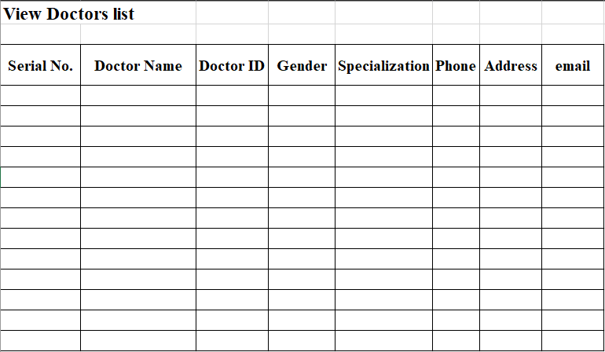

### View Nurses Report & Mock-up

**SYSTEM DOCUMENTATION**

NAME OF SYSTEM DATE PAGE 1 OF 2

Reports System 24-01-2020

ANALYST PURPOSE OF DOCUMENTATION

Kapli Generate and display a List of all the Nurses

|  |  |  |
| --- | --- | --- |
| FIELD | FIELD TYPE | FIELD LENGTH |
| nurseID | Numeric | 10 |
| name | Alphanumeric | 255 |
| gender | Alphanumeric | 255 |
| phone | Numeric | 10 |
| address | Alphanumeric | 255 |
| email | Alphanumeric | 50 |

COMMENTS

1. nurseID will be displayed at the top of the report.

SORT SEQUENCE

Detail lines are in order by nurseId or it can be order based on an alphabetic.

TOTALS REQUIRED

Not Applicable

MEDIA

1. This report can be displayed on the screen.
2. This report can be printed on regular A4 paper.
3. This report can be exported to Excel format.

FREQUENCY

1. Reorganize the nurse and their roles into different departments
2. To schedule the shifts for the nurses

DISTRIBUTION

The report is accessed by the Admin, HR, and the Head of department of nursing using their account

ATTACHMENTS

Mock-up below.

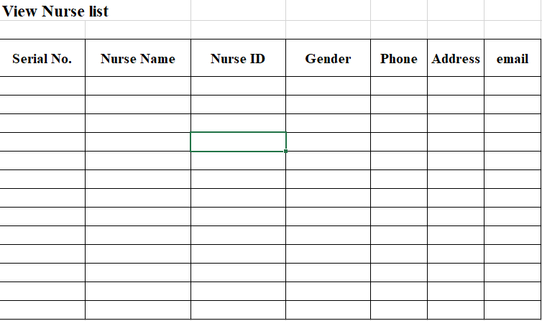

### View Patients Report & Mock-up

**SYSTEM DOCUMENTATION**

NAME OF SYSTEM DATE PAGE 1 OF 2

Reports System 24-01-2020

ANALYST PURPOSE OF DOCUMENTATION

Gilbert Generate and display a List of all the Nurses

|  |  |  |
| --- | --- | --- |
| FIELD | FIELD TYPE | FIELD LENGTH |
| patientID | Numeric | 10 |
| name | Alphanumeric | 255 |
| health card number | Numeric | 20 |
| date of birth | Alphanumeric | 15 |
| gender | Alphanumeric | 255 |
| phone | Numeric | 10 |
| address | Alphanumeric | 255 |
| email | Alphanumeric | 50 |

COMMENTS

patientID will be displayed at the top of the report.

SORT SEQUENCE

Detail lines are in order by patientId or it can be order based on an alphabetic.

TOTALS REQUIRED

Not Applicable

MEDIA

1. This report can be displayed on the screen.
2. This report can be printed on regular A4 paper.
3. This report can be exported to Excel format.

FREQUENCY

1. daily after working hours
2. Weekly after working hours
3. Monthly after working hours

DISTRIBUTION

The report is accessed by the Admin, HR, and the Head of department of nursing using their account

ATTACHMENTS

Mock-up below.

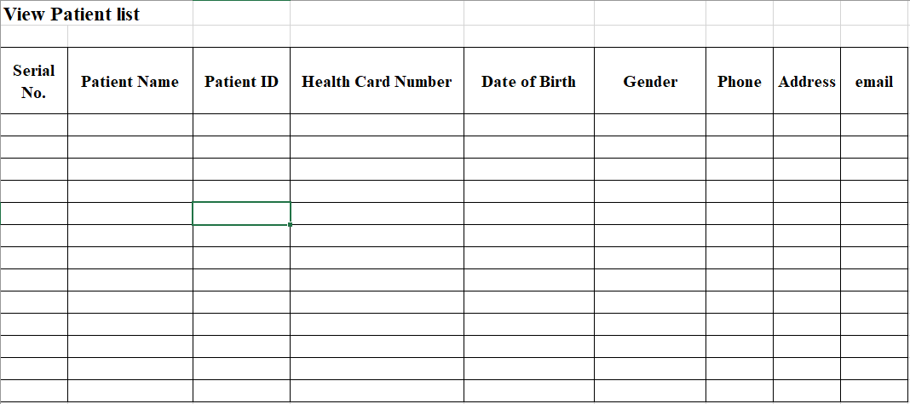

### View Patients medical Record

**SYSTEM DOCUMENTATION**

NAME OF SYSTEM DATE PAGE 1 OF 2

Reports System 24-01-2020

ANALYST PURPOSE OF DOCUMENTATION

MD Generate and display a List of all the Nurses

|  |  |  |
| --- | --- | --- |
| FIELD | FIELD TYPE | FIELD LENGTH |
| patientID | Numeric | 10 |
| name | Alphanumeric | 255 |
| date of birth | Alphanumeric | 15 |
| gender | Alphanumeric | 255 |
| weight | Alphanumeric | 3 |
| height | Alphanumeric | 3 |
| pulesRate | Alphanumeric | 3 |
| bloodPressure | Alphanumeric | 10 |
| lastVisitDate | Alphanumeric | 15 |
| nurseNote | Alphanumeric | 255 |
| diagnose | Alphanumeric | 255 |

COMMENTS

Patient name patient date of birth, gender will be displayed at the top of the report.

SORT SEQUENCE

Detail lines are in order by patientId or it can be order based on an alphabetic.

TOTALS REQUIRED

Not Applicable

MEDIA

1. This report can be displayed on the screen.
2. This report can be printed on regular A4 paper.
3. This report can be exported to Excel format.

FREQUENCY

Every time that the patient has an appointment with their doctor

DISTRIBUTION

The report is accessed by the Admin, HR, and the Head of department of nursing using their account

ATTACHMENTS

Mock-up below.

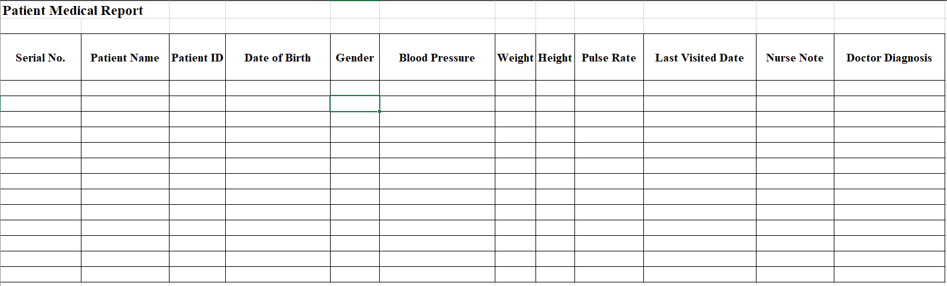

## Input Design

### Register a patient mock-up form

The form below is the Patient registration form. Patients are allowed to register an account, but they must have, alongside other details, their Health card number to do that.

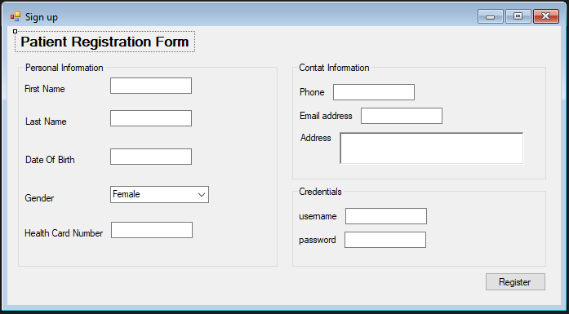

### Doctor and Nurse Registration

Below is the account registration form which the Admin uses to create an account for a patient, Nurse, and Doctor. The radio button is used to select the appropriate user needed to have an account created for.

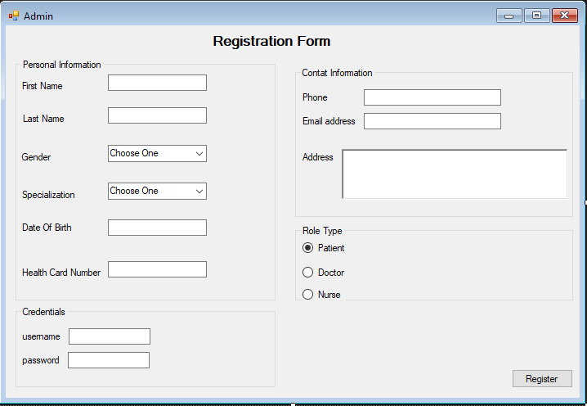

### Create Medical Record

The form below is the Patient medical record form which is used by the Nurses to add Patients vital signs information to their account.

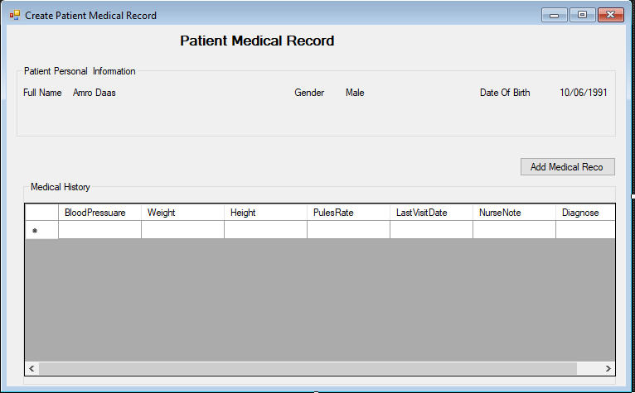

## Database Design

### ERD of the entire system

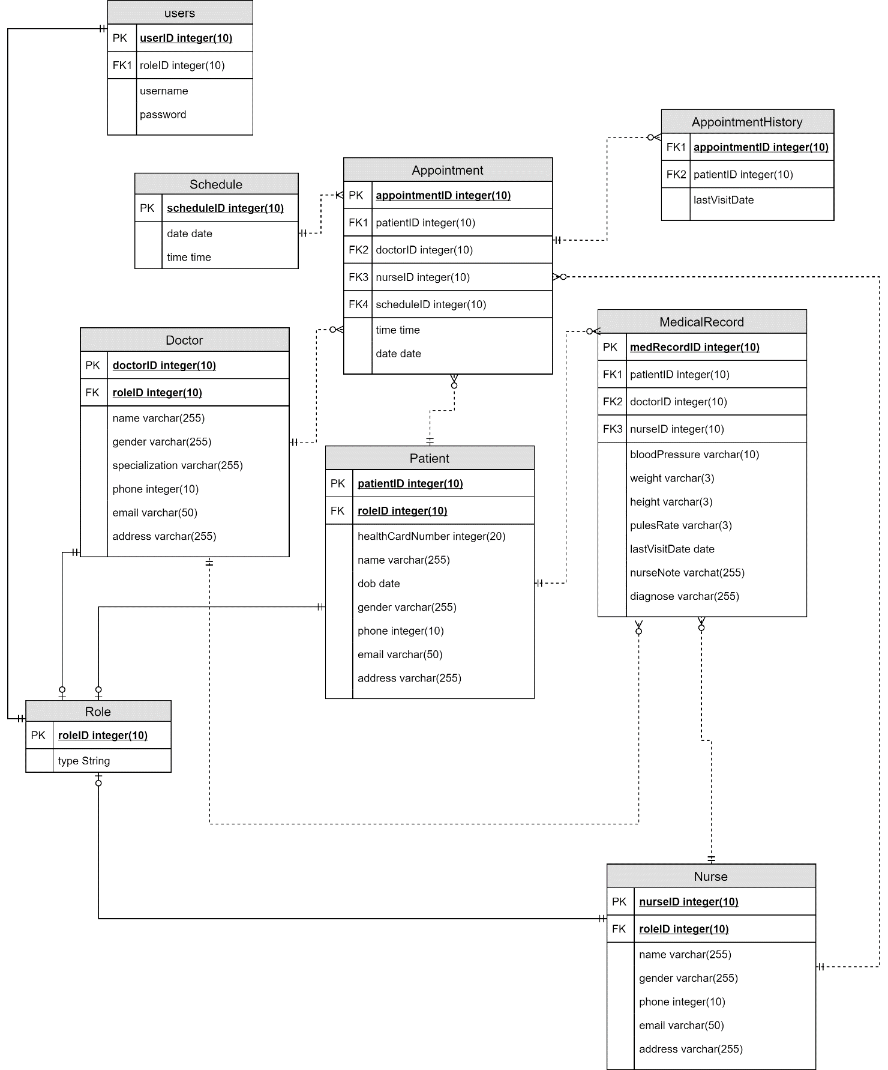

### DateBase Design Language (DBDL)

Doctor (doctorID, roleID, name, gender, specialization, phone, email, address)

SK: phone

FK: roleID

AppointmentHistory (appointmentID, patientID, lastVisitDate)

FK: appointmentID

FK: patientID

Appointment (appointmentID, doctorID, patientID, nurseID, scheduleID, time, date)

FK: doctorID

FK: patientID

FK: nurseID

FK: scheduleID

Schedule (scheduleID, time, date)

Nurse (nurseID, roleID, name, gender, phone, email, address)

SK: phoneNumber

FK: roleID

Patient (patientID, roleID, healthCardNumber, DOB, name, gender, phone, email, address)

SK: phoneNumber

SK healthCardNumber

FK: roleID

MedicalRecord (medRecordID, patientID, nurseID, doctorID, bloodPressure, weight, pulesRate, height, lastVisitDate, diagnose, nurseNote)

FK: patientID

FK: nurseID

FK: doctorID

Role (roleID, type)

Users (userID, roleID, username, password)

FK: roleID

### Database Dictionary

|  |  |  |
| --- | --- | --- |
| Table Name | Attribute Name | Data Type |
| Doctor | doctorID  roleID  name  gender  specialization  phone  email  address | number (10)  number (10)  varchar (255)  varchar (7)  varchar (255)  number (10)  varchar (50)  varchar (255) |
| Patient | patientID  roleID  healthCardNumber  DOB  name  gender  phone  email  address | number (10)  number (10)  number (20)  date  varchar (255)  varchar (7)  number (10)  varchar (50)  varchar (255) |
| MedicalRecord | medRecordID  patientID  nurseID  doctorID  bloodPressure  weight  pulseRate  height  diagnose  nurseNote | number (10)  number (10)  number (10)  number (10)  varchar (7)  varchar (3)  varchar (3)  varchar (3)  varchar (255)  varchar (255) |
| Nurse | nurseID  roleID  name  gender  phone  email  address | number (10)  number (10)  varchar (255)  varchar (7)  number (10)  varchar (50)  varchar (255) |
| Appointment | appointmentID  doctorID  patientID  nurseID  scheduleID  time  date | number (10)  number (10)  number (10)  number (10)  number (10)  time  date |
| schedule | scheduleID  date  time | number (10)  date  time |
| Role | roleID  type | number (10)  varchar (255) |
| Users | userID  roleID  username  password | number (10)  number (10)  varchar (255)  Varchar (255) |
| AppointmentHistory | appointmentID  patientID  lastVisitDate | number (10)  number (10)  date |

### Support Processing Design

#### List of forms needed to support the computer system

Below is a list of forms that needed to support the computer system use:

* Sign up/Registration
* Create Doctor account
* Create Nurse account
* Contact Us
* Patient login
* View Doctor
* View Nurse list
* Appointment Scheduling
* View Appointments
* View Doctor schedule

# Environmental Requirement

## Hardware required by the new system

Below are the minimum hardware requirements for implementing the system:

* Laptop/Desktop with the following specifications:
* *Core i7 processor*
* *8GB RAM*
* *5GB hard disk space*
* *5GB hard disk space on Server Machine*
* Wi-Fi Internet or LAN connection equipment

## Software required by the new system

Below are the software requirements for implementing the system:

* PhpStorm IDE 2019.2.1
* Windows 10 operating system
* Languages/Styling: PHP, HTML, CSS
* Database: MySQL
* ThirdParty package manager: npm
* ORM Framework: Illuminate
* Testing Framework: PhpUnit
* Package manager: Composer
* Source Control: Git
* Hosting: HCCIS

Facility addition or modification required by the new system

Facility would need to provide for a dedicated server room and laying of cables and connections for the computers at the user desk.

Staff Required

The staff required for the operation of the system are as follows:

* System Administrator
* Nurses
* Doctors
* CIS Implementation team (external)

# Implementation Requirements

## Data conversion/data entry requirements

Input forms are structured to accept only valid data from users. No form data conversion is included in this design.

## Security consideration and levels of access to the system

The System Administrator has a unique login credentials so system can understand no intruders can change or manipulate records and valuable data. Administrators create accounts for Doctors and Nurses and can delete any record from the system. Patients have rights to only register an account, view their profile information, and view their appointments history. They are not allowed access to their medical record and the Doctor’s diagnostic notes. Nurses can create an account for a patient, create medical records for patients and view Doctors’ diagnostic notes. Doctors have access to a patient's medical records and allowed to update them and add notes.

## Approach and recommendation for system changeover

Implementation is the stage of the project when the design is turned out into a working system. It is considered to be the most critical stage in achieving a successful new system and in giving the user, confidence that the new system will work and be effective. The implementation stage involves careful planning, investigation of the existing system and the constraints on implementation.

The parallel operation changeover method is recommended as it requires that both old manual system and the new information systems operate fully for a specified period. When users, management, and the IT group are satisfied that the new system operates correctly, the manual system is terminated.

The advantage of parallel system is lower risk of system failure so all the tasks can be done properly at health centre. If the new system does not work properly, the health centre can use the old manual system as a backup until appropriate changes are made.

## Training Requirements

We do not assume that all the intended users of this system are skilled in the use of an application of this magnitude. That said, we intend to have all the hospital personnel trained on-site before the system goes live.

## Post-implementation reviews

After the DOUH HMS has been installed, we shall carry out a post implementation evaluation to ascertain the overall quality of the system, verify the specified requirements are met, verify the expected benefits are met, and ascertain the overall user satisfaction. To achieve the evaluation, we shall be carrying out the following:

* Interview of the users of the system. Users here include Patients, Nurses, hospital System Administrator, and Doctors.
* Workshops where we shall have a review of the requirements stated at the beginning, comparing those with what the deployed system delivers
* Testing of the system at the site, and off-site as a Patient